

**Module Code & Module Title**

**CS6P05NI Final Year Project**

**Assessment Weightage & Type**

**25% FYP Interim Report**

**Semester**

**2022 Autumn/Spring**

**Project Title:** My Room

**Student Name:** Anish Aryal

**London Met ID:** 20048825

**College ID:** np01cp4s210084

**Internal Supervisor:** Aadesh Tandukar

**External Supervisor:** Brij Sharma

**Assignment Due Date:** 28th Dec, 2022

**Assignment Submission Date:** 28th Dec, 2022

### Word Count (Where Required): 3753

*I confirm that I understand my coursework needs to be submitted online via Google Classroom under the relevant module page before the deadline in order for my assignment to be accepted and marked. I am fully aware that late submissions will be treated as non-submission and a mark of zero will be awarded.*

**Summery**

This project involves the development of a web application for a property rental and sales platform. The project has made significant progress so far, with the initial phase and several subsequent tasks being completed. These tasks include research and planning, gathering resources, developing a risk management plan, creating a Gantt chart, designing the system architecture and user interface, and preparing various documents and diagrams. The project is currently in the development phase, with work underway on the login/register module. The remaining tasks, which include the development of various pages and features, finetuning and testing of APIs, and final testing and reviews, are yet to be started. The project is on track to be completed by April 2023 and the conclusion has been reached that the remaining tasks will be completed efficiently and on schedule.

# Introduction

## Project Description

First thing a person search for while planning to migrate from one place to another is a place to stay after reaching the destination. A room/apartment is mostly preferred by the students and working professionals who constantly need to travel from one place to another. However, there is no reliable platform for you to find a room/apartment of your choice. This complicates things a lot as you cannot shift to a new place without finding a home to stay and searching on the physical site may not be possible for most people.

The product being built for this project is room/apartment finding web application which will help the customers to negotiate or make a deal the property directly with the owner and to make the user experience as effective and efficient as possible this project will have maximum time limit/expiry-date of 1 month on the ads of the property posted by the user. A user can be a customer and seller as he/she can buy a property and sell their own property.

## Problem Scenario

1. People need to roam physically to find a room or apartment either to buy or rent.
2. There are few websites which claim to help people to find the property of their type however, most of them are run by the agencies however they are not active on the website.
3. There is no dedicated platform for the customer to find the property they need without any
4. As there are no alternatives for finding the property the customer need, finding the room for people who are planning to shift to major cities of Nepal face a lot of problems especially for students and working professionals as they don’t have their established source of income and time on their hand to roam around to search physically.
5. Most websites in Nepal which claims to help find people property to live in they got too old ads like 5–6-year-old which makes the experience for the customer troublesome.

## Project as a solution

This project will act as the best possible solution for the above-mentioned problem in the context of Nepal. With the time limit on the ad of property posted by the seller, customer can benefit the most as they will get to know how old the ad is and since there will no ads that are of before 30-day customer can surf the website with ease to find the property they need.

People can directly interact with the owner by using the contact info given by the owner on the post or in the comment section of the property ad’s details. The details on the ad include property details, owner details, property location and picture of property and surrounding. There will also be the embedded map which shows the location of the property so the customer can easily go and visit the owner in person and deal with them. Maps will further show the nearby schools, Hospitals, Markets near the property.

## Aims and Objective

The aim of this project is to create a room finding web application. Which can solve the above mention problems people are facing while finding the rooms in major cities of Nepal.

The objectives which are the basis of the completion of the project are:

* To learn about web application and their workings.
* To use build a room finder web application at the end of the project
* To understand and implement usage of database along with web application.
* To learn about user interface.
* To understand about API programming.
* To deliver a complete functional product at the end of the project

## Structure of Report

### Background

This chapter provides a clear insight into solution and further clarifies the requirements of the project. It also includes a detailed client description, review of similar systems, and technical aspects of the project.

### Development

Development section of the report consists of detailed consideration of the design and development of the web application. It covers all the work related to the development of the project including the chosen software development methodology and its phases.

### Testing and analysis

This section of the report is based on test plans, unit testing, system testing, and critical analysis of the test procedures. It consists of the process related to white-box testing, black-box testing, integration testing, and client evaluation testing.

### Conclusion

This chapter concludes the project report by discussing wider implications of the developed web application, and future improvements in the project.

# Background

## End-Users

This application id targeted towards those people who are looking for a platform to sell or lease their property and also for those individuals who are looking to buy or rent properties to live in like apartments and rooms. More importantly this is the web application which will make it easier for sellers to find potential buyers without any hassle. Mainly there are two users one is buyer and another is seller.

### Sellers

The sellers are individuals who are interested in selling or leasing their properties. These may include homeowners, landlords, property investors, or real estate agents. The platform allows them to list their properties and reach out to potential buyers without any hassle. By using the application, sellers can easily upload pictures of their properties, provide detailed descriptions, and set the price or rent that they are looking for. They can also use the platform to communicate with potential buyers and negotiate deals.

### Buyers

The buyers are individuals who are interested in purchasing or renting properties. These may include individuals who are looking for apartments, rooms, or houses to live in. By using the platform, they can easily search for properties that meet their needs and preferences. They can also use various filters to refine their search and find the properties that fit their budget and location preferences. Additionally, the application provides detailed information about the properties, such as pictures, floor plans, amenities, and location details. Buyers can also use the platform to communicate with sellers, schedule property visits, and make offers.

## Functions and Features

## Main Features

#### Online Ad Posting

Enables users to post property ads online for potential buyers and renters to view.

#### Option for Seller to Specify Sale or Lease

Gives sellers the choice to advertise their property as for sale or for lease.

#### Expiry Date of 30 Days on All Ads Posted

Limits the duration of ads to 30 days to ensure that the platform displays up-to-date property listings.

#### Visible Time Since Ad Posted for Users

Displays the time since the ad was posted to provide users with a sense of how long the property has been listed.

#### Ads Disappear After Expiry

Automatically removes expired ads from the platform and notifies the seller of the ad's removal.

#### Option to Repost Ad if Property Remains Available

Allows sellers to repost their ad if the property is still available after the ad's expiration.

#### Embedded Map Displayed in Property Details (Mandatory)

Requires sellers to include a map of the property's location in the listing details.

#### Image Upload

Requires sellers to upload images of the property and its surroundings before making the ad public.

#### Property Filter Options for Rent, Buy, or Both

Enables users to filter listings based on whether the property is for rent, for sale, or both.

#### Advanced Property Search Function

Provides users with a search function that allows for advanced filtering based on criteria such as location, price, and size.

#### Buyer Wishlist Functionality

Enables buyers to save properties they are interested in to a Wishlist for future reference.

#### Property Details

Allows sellers to include details about the luxuries and amenities of the property, such as whether it is furnished or has parking.

## Secondary Features

#### Nearby Schools and Hospital on the map

Shows the location of nearby schools, markets, and hospitals in relation to the property.

#### Property Filter for Pets Allowed/Not Allowed

Provides a filter option for users to search for properties that allow or do not allow pets.

#### Seller Video Uploads for Virtual Property Tours

Allows sellers to upload videos of the property for potential buyers to view.

#### Report Feature to Flag Inappropriate Ads

Allows users to report ads that violate the platform's terms of service.

#### Admin Action on user

Notifies administrators of repeated violations and allows them to take appropriate actions, such as removing the ad or blocking the user.

## Similar Systems

### Room Finder Nepal

Roomsfindernepal is a web-based application. Rooms Finder Nepal is located at: Manamaiju, Kathmandu, Nepal 46000. According to alexa, roomsfindernepal.com has a global rank of #6991232 and it has some SEO issue. This site allows people to search for the property people need in their web. (Room Finder Nepal, 2022)

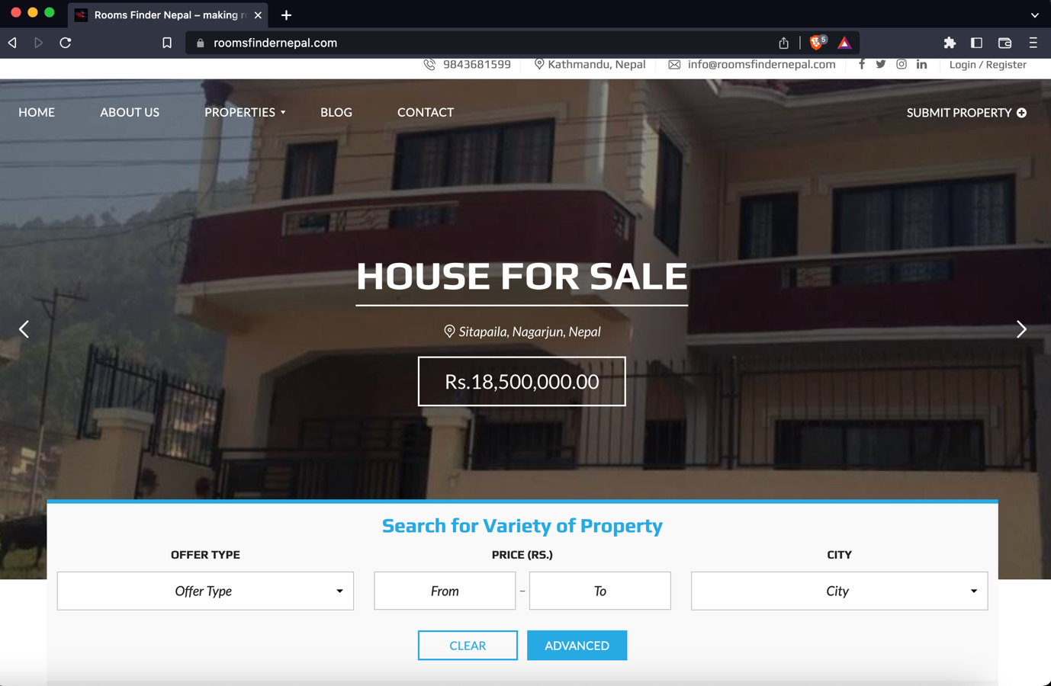

Figure 1: (Room Finder Nepal, 2022) Room Finder Nepal

### Gharbeti

Gharbeti is a web platform that provides a comprehensive list of available rental properties in Nepal, including buildings, apartments, rooms, hostels, and land. Users can search and book these properties online, and the list is regularly updated with detailed information. It offers an efficient way for people to find and book the perfect rental property. (Gharbeti, 2022).

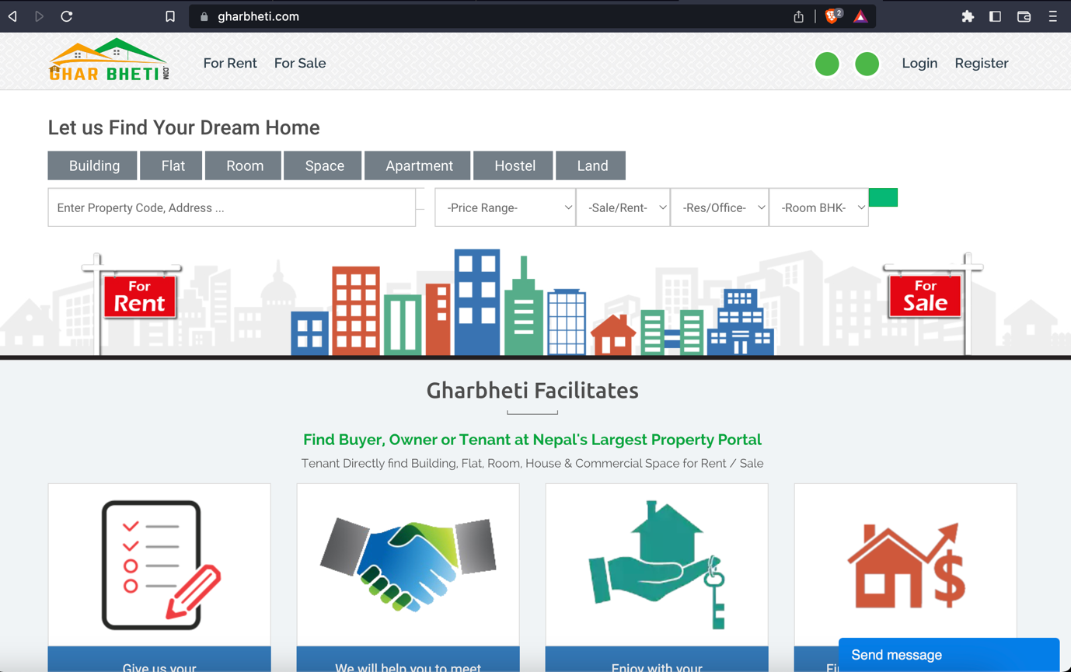

Figure 2: (Gharbeti, 2022) Gharbeti

### DalayDai

DalayDai.com is a free online platform for buying and selling Houses, Lands and everything Real Estate. dalaydai.com makes, searching a perfect Home or a perfect plot of Land for Nepali people effortless and easy like it has never been. With frequent updates to the platform (Dalay Dai, 2022).

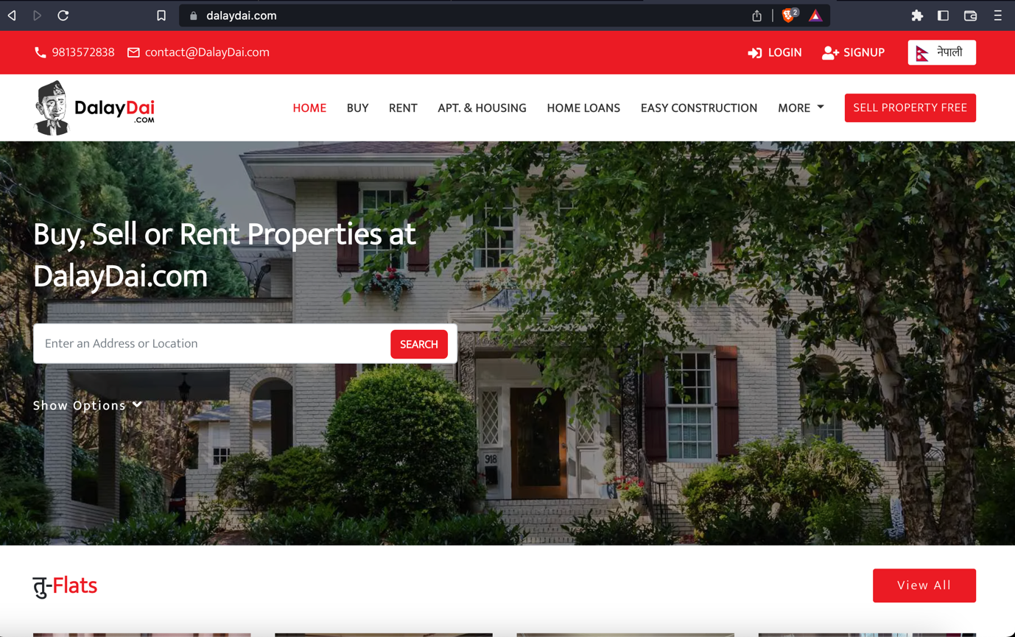

Figure 3: (Dalay Dai, 2022) Dalay Dai

### Hamro rental

Hamro Rental is a free online platform for buying and selling Houses, Lands, Apartments Shops. However, this site seems to be inactive of long time and the user experience while using this site is also not that great. (Hamro Rental, 2022)

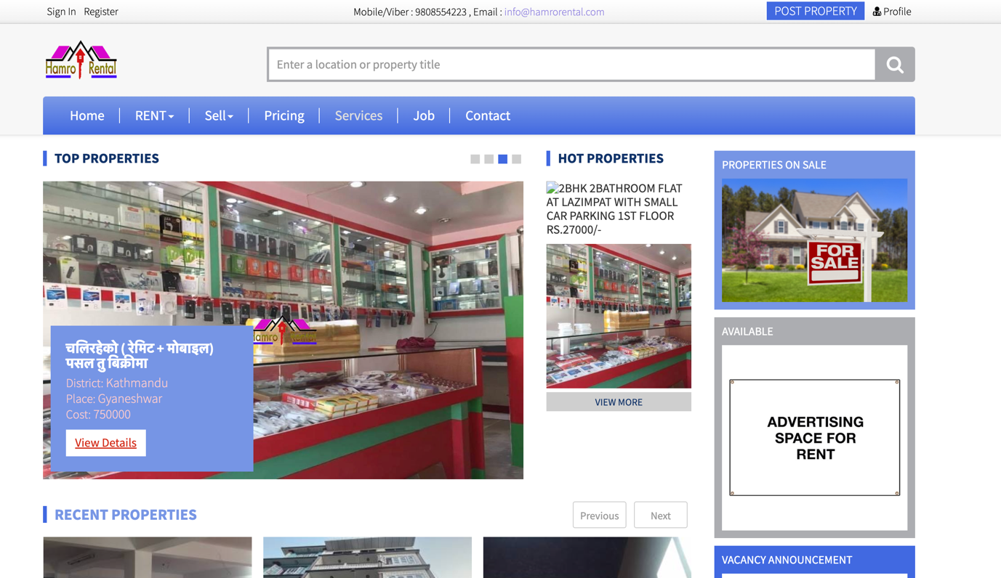

Figure 4: (Hamro Rental, 2022) Hamro Rental

## Comparison Between the Systems

|  |  |  |  |  |  |  |
| --- | --- | --- | --- | --- | --- | --- |
| **S.N.** | **Features** | **Similar Projects** | | | | |
| **Room Finder Nepal** | **Gharbeti** | **DalayDai** | **Hamro Rental** | **MYRoom (My Project)** |
| **1** | Advance Search Feature | **Checkmark** | **Checkmark** | **Checkmark** | **Checkmark** | **Checkmark** |
| **2** | Wishlist | **No sign** | **No sign** | **Checkmark** | **Checkmark** | **Checkmark** |
| **3** | Location | **Checkmark** | **Checkmark** | **No sign** | **No sign** | **Checkmark** |
| **4** | Ad Expiry Time | **No sign** | **Checkmark** | **Checkmark** | **No sign** | **Checkmark** |
| **5** | Comments in ads | **Checkmark** | **No sign** | **Checkmark** | **Checkmark** | **Checkmark** |
| **6** | Realtime Chat | **No sign** | **No sign** | **No sign** | **No sign** | **Checkmark** |
| **7** | Report unreliable ads | **No sign** | **No sign** | **No sign** | **No sign** | **Checkmark** |
| **8** | Pet Allowed Filter | **No sign** | **No sign** | **No sign** | **No sign** | **Checkmark** |
| **9** | Show Nearby Schools, Markets, Hospitals in map view for property | **No sign** | **No sign** | **No sign** | **No sign** | **Checkmark** |
| **10** | Upload Video tour for the property | **No sign** | **No sign** | **No sign** | **No sign** | **Checkmark** |

Table 1: Comparison Between Similar systems

# Development

## Considered Methodology

### Scrum Methodology

(Digite, 2019)Scrum is an agile software development technique that relies on incremental and iterative methods. Scrum is an agile framework that is quick, flexible, adaptable, and effective and is made to provide value to the client throughout the course of the project. Through an atmosphere of open communication, shared ownership, and constant improvement, Scrum's main goal is to serve the needs of the client. The development process begins with a general understanding of what needs to be created, then the product owner develops a list of desired qualities that are prioritized (product backlog).

* + 1. **RUP**

(Minott, 2022) The Rational Unified Process (RUP) definition, also known as the Unified Process Model, is a web-enabled, object-oriented software development process. Object-oriented software engineering refers to any software development approach that uses visual models organized around objects and iteratively goes through analysis, design, and implementation. The RUP framework was created by International Business Machines Corporation (IBM) in 2003 and was one of the first widely used iterative methods.

## Selected Methodology

### Evolutionary Prototyping

The methodology chosen for this project is Evolutionary Prototyping because this methodology provides project with the most flexibility. Since this is the first project, at this big scale working individually. The system might be developed with some modules/ features like I had hoped and the work flow might have been disturbed however That will not be the case anymore because this methodology help solve that issue as modules during in the development phase are independent to one another even if the development got stuck on some problems on one of the modules, that module could be kept on hold and also can keep working on other parts. There will also be feedbacks given by the supervisors’ after completing a module The system could further be optimized and make it better with the help of supervisors’ advice and further research.

The concept is to give the user with an initial prototype. They provide feedback and improvement suggestions. The developer takes action on these and then offers a more improved prototype. The user provides input once more. The procedure is then repeated. As a result, the prototype 'evolves' towards the final system at each iteration. (Teach-itc, 2022)

Advantage of this methodology is that the end user can interact with the prototypes and which increases the user engagement and the feedback given by the user will help improve the product to its optimal glory. This system will be very efficient to meet the user’s requirement.

S

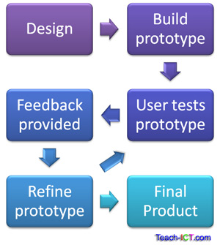

Figure 5: (tech-ict, 2022)Evolutionary Prototyping

### Phases of Evolutionary Prototyping

## Resource Requirement

These Technological Requirements are explained below in appendix section’s Resource Requirement

### Software Requirements

1. IDE VS code
2. HTML, CSS, JavaScript, Bootstrap and React js will be used for the front-end.
3. Node JS, Next JS will be used for backend
4. MongoDB will be used for the database.

### Hardware Requirement

* A reliable Laptop to work on so MacBook pro will be used for this project

# Appendix

## 

## SRS Document

### Project Title: My Room

### Category: Web Application

### Introduction

#### Purpose

When developing software, the requirements stage involves the creation of Software Requirements Specifications (SRS) (also called a requirements document). This report is created after all requirements have been collected, assessed, and laid out, serving as a foundation for software engineering initiatives. In order to help clients, determine whether the report (SRS) meets their needs, it is a formal report that also acts as a software representation. The prerequisites for both users and the system are carefully described as well.

The purpose of this SRS is to specify the requirements for the room/apartment finder web application, which will allow users to search for and list properties for lease or sale and make the process of finding rooms/apartments seamless.

#### Project Scope

The proposed room/apartment finder web application is a platform that allows users to search for and find rooms or apartments to rent or buy. The room/apartment finder web application will include a login and registration system, a chat feature, a comment feature, a property listing feature, a map showing the location of properties, a search and filtering function, a feature for reporting inappropriate listings, etc. The application will also allow users to upload images and videos of their properties. The application will be developed making it proper responsive and optimized for the use in the desktop websites and for mobile devices as well. It allows users to list their own properties for rent or sale, and to interact with other users through a chat feature.

Some potential advantages of this system for people are:

* + 1. **Convenience**: The room/apartment finder web application provides a centralized platform for users to search for and find rooms or apartments, saving them the time and effort of searching through multiple sources.
    2. **Ease of use**: The application has a user-friendly interface and various features, such as an advanced search option and easy filtration options, to make it easy for users to find properties that meet their specific needs and preferences.
    3. **Increased visibility**: The application allows users to list their own properties, providing them with increased visibility and the opportunity to reach a wider audience of potential renters or buyers.
    4. **Communication**: The chat feature allows users to communicate with each other and ask questions about properties, facilitating the process of finding and securing a room or apartment.

### Overall Description

#### Product Description